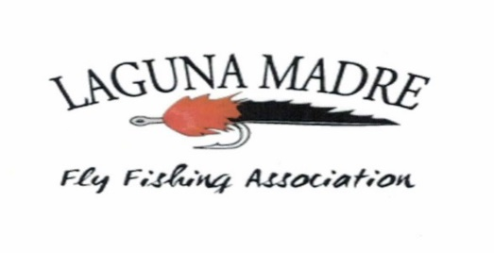

Come and join us for the

1st Annual Laguna Madre Fly Fishing Association’s Redfish Round-UP TOURNAMENT!

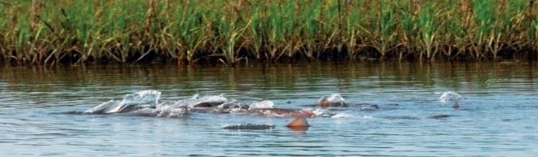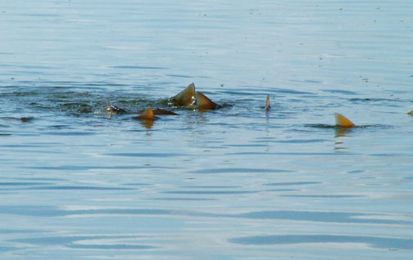
Saturday July 16th from 6:00am to 3:30pm!
Registration is at the Longhorn BBQ (Cattle Co.) by 7:00pm Friday eve the 15th of July
3055 W. Expressway 83 San Benito, TX 78586 (956) 399-4400
Each party is responsible for thier own tab.
A $10.00 entry fee for members, $45.00 for non-members (Which includes membership throughout 2016)!
A social for ALL follows the fishing tournament, will be hosted by Bryan and Michelle Robinson
(27074 FM 1846, San Benito, TX 78586 Bryan’s cell: 956-241-5520)
This includes a Gumbo meal and beverages at 6:00pm, awards at 7:00pm!
1st place fly fishing winners receive a $50.00 gift certificate to Bass Pro Shop 2nd place a $25.00 Gift certificate! YOU CAN BE ONE OF THE SIX WINNERS!
1st place and 2nd place longest single Redfish!
1st and 2nd place total length combined Redfish!
1st and 2nd place total number of Redfish!
OR YOU COULD ALSO WIN,
SOME ITEMS UP FOR A RAFFLE FOR ALL WHO ATTEND SATURDAY EVENING!
PLEASE RSVP at Lmffaflyclub@gmail.com
All Redfish entries must be photographed on a readable measuring device with your name and sent to Lmffaflyclub@gmail.com or text to 956-266-5866 by 4:30pm. You can only place one time in this event!
See Y’all there Ye-HAW!
YOU CAN ONLY USE YOUR FLY ROD, LEAVE YOUR LASSO AT HOME!
FOR MORE INFORMATION OR QUESTIONS PLEASE FEEL FREE TO CONTACT MARK MACHADO AT (956) 266-5866

